**Planning Services**

Gateway Determination Report

|  |  |
| --- | --- |
| **LGA** | Blacktown City Council |
| **PPA** | Blacktown City Council |
| **NAME** | Reclassification of Council land from Community to Operational (0 homes, 0 jobs) |
| **NUMBER** | PP_2018_BLACK_007_00 |
| **LEP TO BE AMENDED** | Blacktown LEP 2015 |
| **ADDRESS** | 91 Main Street Blacktown |
| **DESCRIPTION** | Lot 5A DP 11349 |
| **RECEIVED** | 11 September 2018 |
| **FILE NO.** | EF18/34934 |
| **POLITICAL DONATIONS** | There are no donations or gifts to disclose and a political donation disclosure is not required |
| **LOBBYIST CODE OF CONDUCT** | There have been no meetings or communications with registered lobbyists with respect to this proposal |

**INTRODUCTION**

**Description of planning proposal**

The Planning Proposal seeks to reclassify the subject land from ‘community’ to ‘operational’ land, by amending Schedule 4 of Blacktown Local Environmental Plan (BLEP) 2015.

The reclassification of the land will facilitate the Warrick Lane development which is a key component of Council’s Community Strategic Plan ‘Our Blacktown 2030’. The draft plans for the Warrick Lane development propose the relocation of an existing at-grade public car park into a basement car park and the provision of at-grade public recreational space at 81-97 Main Street, Blacktown.

**Site description**

Lot 5A DP 11349, 91 Main Street, Blacktown and is located within the city centre. The site is shown in Figure 1. The site is a rectangular lot and is zoned RE1 – Private Recreation under BLEP 2015. The land was acquired by Council on 21 December 2017 and the site is currently vacant.

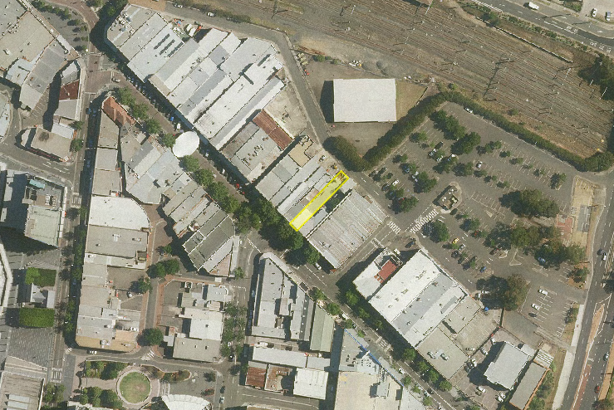

Subject site

**Figure 1. Subject site**

**Surrounding Area**

The site is located within the Blacktown Central Business District (CBD). The subject site forms part of Warrick Lane development consisting of 81-97 Main Street, Blacktown. These lots, with the exception of the subject site are classified as operational land. The site is adjoined by:

* Council owned land to the east (93 Main Street);
* Council owned land to the west (89 Main Street);
* Public car park to the north; and
* Main Street to the south.

**Existing planning controls**

The subject site is zoned RE1 – Public Recreation. No height of building or floor space ratio controls applies to the site as it is zoned for public recreation. An extract of the landing zoning map is provided below in Figure 2.

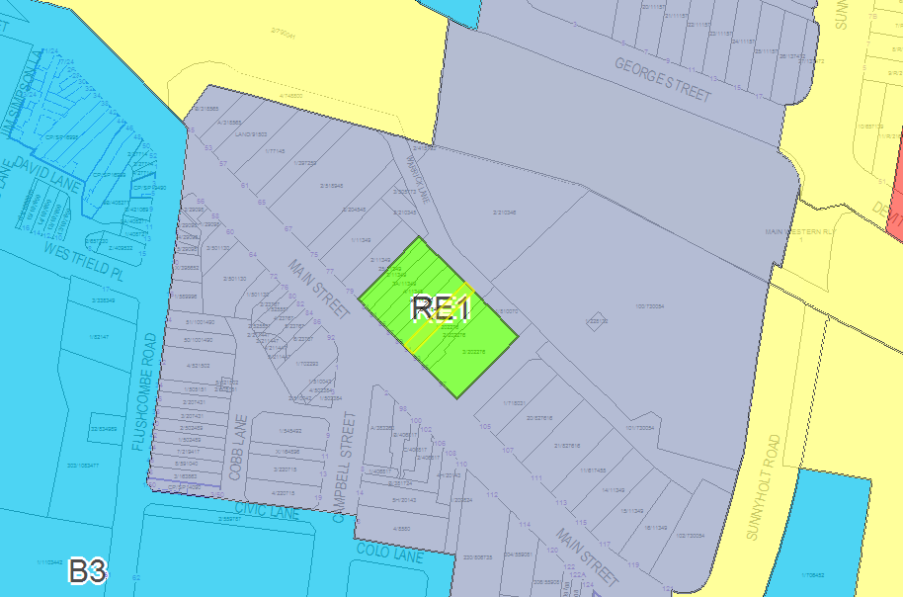

Subject site

**Figure 2. Land Zoning Map**

**Summary of recommendation**

The planning proposal has merit and should proceed subject to conditions as it will facilitate the Warrick Lane development Council’s Community Strategic Plan ‘Our Blacktown 2030’.

**PROPOSAL**

**Objectives or intended outcomes**

The objective of the planning proposal is to reclassify Council owned land from community land to operational land.

All Council owned land in NSW is classified as either 'operational land' or 'community land'. Community land generally includes public access lands such as parks and reserves. Community land is not able to be sold by a council. Operational land is not generally open to the public, but may be used for public purposes such as works. Operational land can be sold or developed for private use.

The reclassification of the subject site to 'operational land' is necessary to facilitate the Warrick Lane development, as follows:

* The draft plans for the Warrick Lane development includes the relocation of existing at-grade car parking spaces into a basement carpark below the RE1 Recreation zoned land at 81-97 Main Street, Blacktown. The subject site needs to be classified as operational land to enable operation of the basement carpark on the site, as no Plan of Management applies to this site that enables its use for a public carpark.
* With the exception of the subject site, the adjoining properties zoned RE1 are classified as operational land. As such, the Planning Proposal is required to reclassify 91 Main Street from community to operational land consistent with the adjoining lots, to enable the operation of the basement carpark as part of the Warrick Lane development.

**Explanation of provisions**

The planning proposal seeks to amend the BLEP 2015 by reclassifying the site from community to operational land.

The reclassification will occur by amending Schedule 4 *Classification and reclassification of public land* of the BLEP 2015 to include the site in Part 1 *Land classified, or reclassified, as operational land—no interests changed*, as shown in Table 1

Table 1 – Proposed insertion in Part 1 of Schedule 4 of the BLEP 2015

|  |  |
| --- | --- |
| **Column 1** | **Column 2** |
| **Locality** | **Description** |
| Blacktown | Lot 5A DP 11349  91 Main Street, Blacktown |

It is also noted that Council does not intend to discharge any of its interests such as property ownership.

**Mapping**

As the planning proposal is for the reclassification of land only, no mapping changes will be required.

**NEED FOR THE PLANNING PROPOSAL**

The planning proposal is a result of a strategic study. The planning proposal implements a component of Council’s Community Strategic Plan ‘Our Blacktown 2030’. This is discussed further in this report.

The planning proposal advises that the proposed amendment is the best and most appropriate means of achieving the Council’s intended outcome. A planning proposal is the only means available to the change the classification of Council owned land from community to operational land.

**STRATEGIC ASSESSMENT**

**Regional / District**

Greater Sydney Region Plan

The Planning Priorities of the Greater Sydney Region Plan which apply to the proposal are:

* Objective 4: Infrastructure use is optimised.
* Objective 6: Services and infrastructure meet communities’ changing needs.

Central City District Plan

The actions of the Central City District Plan which relate to the proposal are:

* Planning Priority C1: Planning for a city supported by infrastructure.
  + Action 4: Sequence infrastructure provision using a placed based approach.
  + Action 5: Consider the adaptability of infrastructure and its potential shared use when preparing infrastructure strategies and plans.
* Planning Priority C3: Providing services and social infrastructure to meet people’s changing needs.
  + Action 8: Deliver social infrastructure that reflects the needs of the community now and in the future.
  + Action 9: Optimise the use of applicable public land for social infrastructure.

The planning proposal is consistent with the above objectives and planning priorities as the planning proposal will assist in delivering key social infrastructure for the Blacktown CBD. The Warrick Lane development will provide a basement car park and at-grade public recreation at 81-97 Main Street, Blacktown which will service future residents that will be housed in this part of the CBD over the next 20 years. The use of public land will also be optimised as the ground level can be maximised for recreational activities.

**Local**

Our Blacktown 2036

Council's Community Strategic Plan (adopted 28 June 2017), ‘Our Blacktown 2036’, was developed in partnership with the residents, local community groups, stakeholders and businesses. It expresses the community's vision and aspirations for the future of Blacktown City.

The vision for Blacktown City is that it be a 'City of Excellence — diverse, dynamic, progressive'. Alongside the 6 strategic directions is a set of transformational projects that completes the vision for Blacktown. These projects include:

* Blacktown International Sportspark
  + BISP master plan
  + Internal centre of training excellence
* Blacktown City Centre;
  + Warrick Lane Development
  + University campus
  + Health precinct
  + Council offices
* Riverstone Town Centre masterplan
* Animal rehoming centre.

The planning proposal will facilitate the Warrick Lane development which forms part of the Blacktown City Centre transformation project which is consistent with ‘Our Blacktown 2036’.

**Section 9.1 Ministerial Directions**

The planning proposal is consistent with the applicable Section 9.1 Directions, in particular, Direction 6.2 Reserving land for Public Purposes.

This direction aims to facilitate the provision of public services and facilities by reserving land for public purposes or removing these reservations when the land is no longer required. This direction applies as the planning proposal aims to reclassify community land to operational land. The direction states that a planning proposal must not reduce the existing reservations of land for public purposes without the approval of the relevant public authority and the Secretary’s delegate.

The planning proposal is consistent with this direction as the reclassification of land will not reduce the provision of public services and facilities. Details are as follows:

* The subject site will remain zoned RE1 – Public Recreation, which will facilitate development of public open space or recreational purposes; and.
* The planning proposal will ultimately enable the Warrick Lane development which will consist of public car parking facilities and public recreational space, thereby contributing to the provision of public services and facilities.

**State Environmental Planning Policies**

Given the minor nature of the proposal which seeks to reclassify a portion of land from community to operational land, the planning proposal is considered to be consistent with all State Policies.

**SITE-SPECIFIC ASSESSMENT**

**Social**

The planning proposal purely seeks to reclassify the land. However, the future public recreation and public parking facility that will be developed on the site will be an important piece of infrastructure that will be of a social benefit to the public.

The community engagement process and the public hearing will also allow direct input from the community and may raise matters requiring further examination as the planning proposal evolves and progresses.

**Environmental**

# The site is currently developed and cleared of vegetation, therefore the planning proposal will not have any adverse impacts on the environment.

# Economic

The economic impacts are minimal, as the planning proposal only seeks to reclassify the land.

**Infrastructure**No infrastructure would be provided or removed as part of this planning proposal to reclassify land.

**CONSULTATION**

**Community**

As the proposal is to reclassify land, it is proposed to place the planning proposal on public exhibition for 28 days. Council proposes to notify interested parties of the planning proposal by:

* Notice of the public exhibition in the local newspaper and on the Blacktown City Council website; and
* Letters to adjoining and nearby land owners and occupiers.

A copy of the Department of Planning and Environment's Practice Note PN16-001 — 'Classification and reclassification of public land through a local environmental plan' will be included in the public exhibition material, as required.

As the planning proposal seeks to reclassify public land from community to operational, Council will also hold a public hearing under the requirements of the Local Government Act 1993. This will give the community an opportunity to expand on written submissions and discuss issues with an independent person in a public forum.

**Agencies**

Council has not proposed any particular public authorities or state agencies to consult with. The Department considers that no agency / authority consultation is required given the minor nature of the proposal.

**TIME FRAME**

Council proposes a timeframe of 6 months to finalise this planning proposal. Given the minor nature of the planning proposal a 6 month timeframe is considered appropriate.

**LOCAL PLAN-MAKING AUTHORITY**

Given that the planning proposal affects Council owned land (i.e. the site), it is recommended that authorisation to exercise delegation should not be issued to Council.

**CONCLUSION**

The planning proposal has merit and should proceed subject to conditions as it will facilitate the Warrick Lane development in accordance with Council’s Community Strategic Plan ‘Our Blacktown 2030’.

**RECOMMENDATION**

It is recommended that the delegate of the Greater Sydney Commission, determine that the planning proposal should proceed subject to the following conditions:

1. Public exhibition is required under section 3.34(2)(c) and schedule 1 clause 4 of the Act as follows:
2. the planning proposal must be made publicly available for a minimum of 28 days; and
3. the planning proposal authority must comply with the notice requirements for public exhibition of planning proposals and the specifications for material that must be made publicly available along with planning proposals as identified in section 5.5.2 of *A guide to preparing local environmental plans* (Department of Planning and Environment 2016).
4. No consultation is required with public authorities/organisation under section 3.34(2)(d) of the Act.
5. A public hearing is not required to be held into the matter by any person or body under section 3.34(2)(e) of the Act. This does not discharge Council from any obligation it may otherwise have to conduct a public hearing (for example, in response to a submission or if reclassifying land).
6. The time frame for completing the LEP is to be 6 months following the date of the Gateway determination.

**Ann-Maree Carruthers**

**Director, Sydney Region West**

**Planning Services**

Contact Officer: Rodger Roppolo

Rezoning Officer, Accelerated Rezoning

Phone: 8289 6876